FOR IMMEDIATE RELEASE:

Interview Availability: Living Legends and History and Heritage of the U.S. Navy SEALs

Commander (SEAL) Tom Hawkins USN (Ret.) .
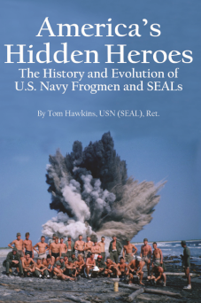
The author of America’s Hidden Heroes: The History and Heritage of the U.S. Navy Frogmen and SEALs served with or supported SEAL teams for 48 years; having retired in May, 2014 from the Combat Development Directorate at the Naval Special Warfare Development Group. He is a pre-eminent historian of U.S. naval commando history and was a featured expert on this year’s PBS documentary Navy SEALs – Their Untold Story.

William “Bill” Dawson WWII Veteran and Last of the First Navy Commandos
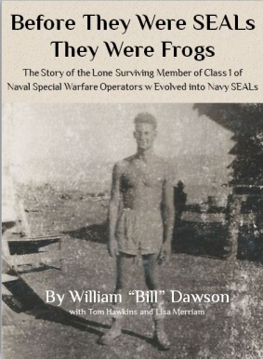
Mr. Dawson is the last living member of 1943 Class 1 of naval commandos (current SEALs-in-training are set to graduate as in Class 312). Bill served with the Naval Combat Demolition Units that stormed beaches across the Pacific Theater of Operations during World War II, often with nothing but a K-Bar knife and bathing suit. He is the author of the compelling story Before They Were SEALs They Were Frogs, the extraordinary accounting of an extraordinary group of men whose legacy can be seen in today’s Navy SEALs.

